BLOG POST

**Foregrounding Indigenous Perspectives**

**Community and Collaborator Affinities and Conflicts in Open Education**

**Subject Line:**

Call for participants: Research project explores Indigenous perspectives in open educational resource development

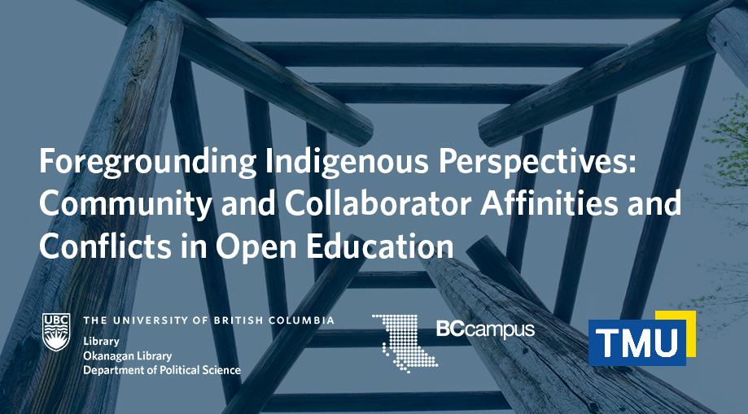

A new collaborative research project, titled Foregrounding Indigenous Perspectives: Community and Collaborator Affinities and Conflicts in Open Education, aims to address a fundamental problem in how open educational practices approach Indigenous Knowledges, and instead replicate colonial concepts of ownership and knowledge transfer. The project will identify gaps in the open education communities’ understanding of Indigenous perspectives through surveys of open educational resource creators, and interviews with Canadian Indigenous faculty, academic educators, librarians and others involved in the creation of open educational resources and initiatives at various universities and colleges. This project is funded by the [Canadian Association of Research Libraries (CARL) Research Grant](https://www.carl-abrc.ca/strengthening-capacity/research-grants/).

“My hope for this project is to have some sense of how we can engage in open educational practices that are grounded in research on Indigenous perspectives. This will be able to unearth our gaps in understanding and balance our advocacy efforts with research-informed practice,” says Erin Fields ([erin.fields@ubc.ca](mailto:erin.fields@ubc.ca)), principal investigator and Open Education and Scholarly Communications Librarian at UBC Library.

“From our findings, we will be able to provide suggestions for people working within open education on how they can engage respectfully with Indigenous communities and Knowledge Keepers and, in doing so, we can help to eliminate the colonial violence being done to Indigenous communities within open education and the broader field of education,” says Donna Langille, Community Engagement and Open Education Librarian at UBCO Library.

“There are a lot of complexities in regards to Indigenous Knowledges and how they are shared, so it’s great to have a group of advocates who can come together to begin to address the concerns that many communities have, while thinking more within a national scope,” says Kayla Lar-Son, Indigenous Programs and Services Librarian at Xwi7xwa Library. “This grant allows us to support Indigenous communities in an area where they are often forgotten and in a way that makes sense with their own protocols and uplifts their voices.”

## Call for Participation – Survey

**Have you created or supported a Canadian Indigenous Open Educational Resources (OER), and are employed by or affiliated with an institution of higher education?**

You are invited to participate in a 15 minutes online survey. Participants who complete the survey in full will be entered into a randomized draw to win 1 of 3 $50 Mastercard Gift Card.

The requirements for participation include:

* You have contributed to Canadian Indigenous OER*
* You are employed or are affiliated in the course of your contribution to the OER to an institution of higher education. This includes faculty, staff, students, and community members.

*\*For the purpose of this study, Canadian Indigenous OER is defined as any openly licensed educational resource that is focused on the history, culture, knowledges, and methodologies of Indigenous peoples and/or guided by the perspective of Indigenous peoples.*

If you are interested in participating, take the survey here:

<https://bit.ly/indigenousOER> [English version]

<https://bit.ly/IndigenousOER_FR> [French version]

## Call for Participation - Interview

**Are you are employed by or affiliated with an institution of higher education, and do you self-identify as Indigenous?** **Are you engaged in teaching and learning?**

You are invited to participate in an interview that will take approximately 60 minutes of your time. An honorarium of $100 will be offered for your participation.

The study is seeking 20 interview participants. The requirements for participation include:

* You self-identify as Indigenous
* You work in/or are affiliated with a Canadian academic institution
* You engage in/or support teaching and learning

The interviews will be held via Zoom and will be recorded for analysis.

If you are interested in participating in an interview and would like more details, including information about participate confidentiality, please express your interest here:

<https://bit.ly/IndigenousOER_EOI> [English Version]

<https://bit.ly/IndigenousOER_EOIfr> [French Version]

*Credit: This post is based on materials originally created by UBC Library Communications*